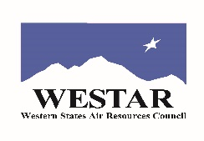
final program agenda for April 5, 2022
WRAP 25th Anniversary Celebration - Park City, UT
(March 29, 2022 version)

Day 1 of WESTAR-WRAP meeting ends ~5 pm

Welcome and opening remarks (10 mins.) (Gordon Pierce, Randy Ashley)
  - Acknowledgement of past/present WRAP Board State and Tribal Co-Chairs and members
  - The first 25 years of WRAP-ing
  - Overview of celebration program

WRAP formation and early evolution panel (15-20 mins.) emcee: Mike Silverstein

WRAP Entertainment (10-15 mins.) (special prizes) emcee: Mary Uhl
- Jeopardy
- Guess that Class I area
- Poems

Regional Haze program, SIP development, analysis/planning effort panel (15-20 mins.) emcee: Tom Moore

Other achievements as a membership organization / hindsight / where are we now panel (20-25 mins.) emcee: Jay Baker

WRAP-up - Gordon and Randy (5 mins.)
- move to Bear Prefunction room for unstructured continuing celebration
- food and drink service starts at 700 pm - appetizers/hors d’oeuvres for dinner, cash bar, non-alcoholic drinks provided
